**Year 8 Rocks Assessment**

Part A: The Rock Cycle

The Rock Cycle is a diagram that shows the slow, continuous process of rocks changing from one type to another. The Rock Cycle is a series of changes. Igneous rock can change into sedimentary rock or into metamorphic rock. Sedimentary rock can change into metamorphic rock or into igneous rock. Metamorphic rock can change into igneous or sedimentary rock.

The rock cycle is an illustration that is used to explain how the three rock types are related to each other and how Earth processes change a rock fro one type to another through geologic time. ***Plate tectonic movement*** is responsible for the recycling of rock materials and is the driving force of the rock cycle

A trip through the rock cycle takes millions of years.

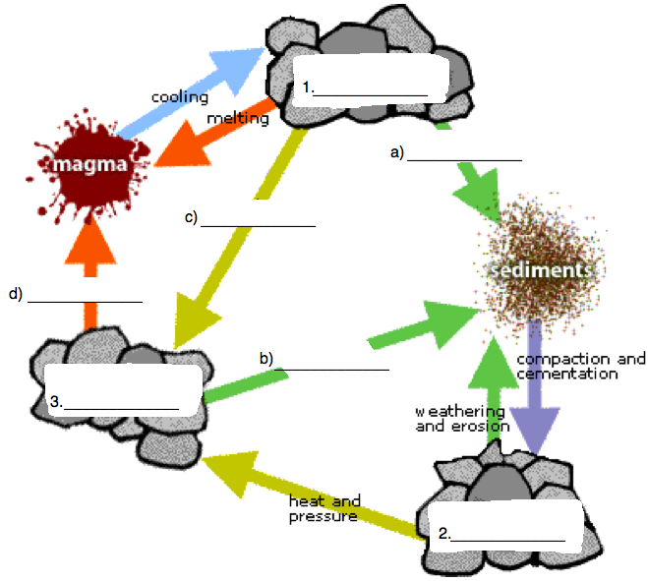

Using the Rock Cycle diagram above:

1. Label the above three rock types, using the spaces provided (boxes 1 – 3).

(3 marks)

1. Label the four processes which help to create each of the rock types, using the spaces provided (lines a – d).

(4 marks)